***EXPERIMENT 5***

***AIM:*** Automate Files backup to aws S3 bucket on Linux machine.

***PROCEDURE:***

1. Create a S3 bucket.

2. Create a EC2 instance.

3. Give EC2 instance Role to access S3.

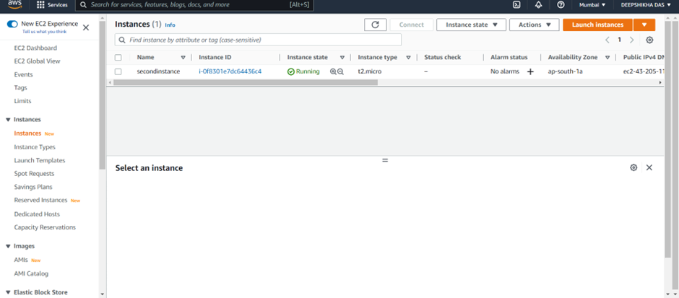

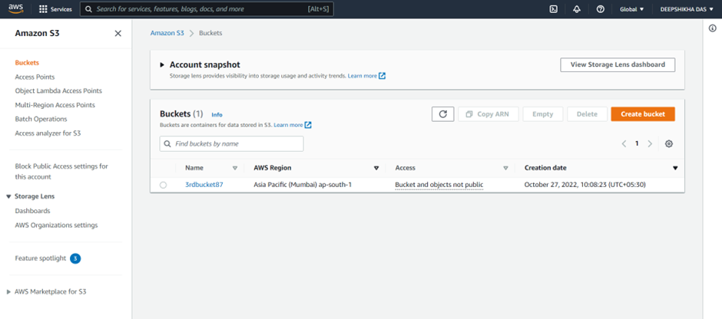

4. Connect to your EC2 instance CLI.

5. Type “sudo su” to give access root directory.

6. Create a director y “backup ”. Type: mkdir back up

7. Go inside the “backup” directory.

8. Make some test files.

Type : touch a

9. List them by cmd – ls

10.Now to sync these files of backup directory on the S3 bucket. Cmd : aws s3

sync localfilepath s3://bucketname

11.Now, we are going to create a cron job in order to automate this process.

Cmd : crontab -e

Enter the cmd : cron code aws s3 sync /directory s3://bucketname

For e.g. : cron code for 1 min is * * * * *

(you may use crontab.guru to create your own job expression)

URL : https://crontab.guru/

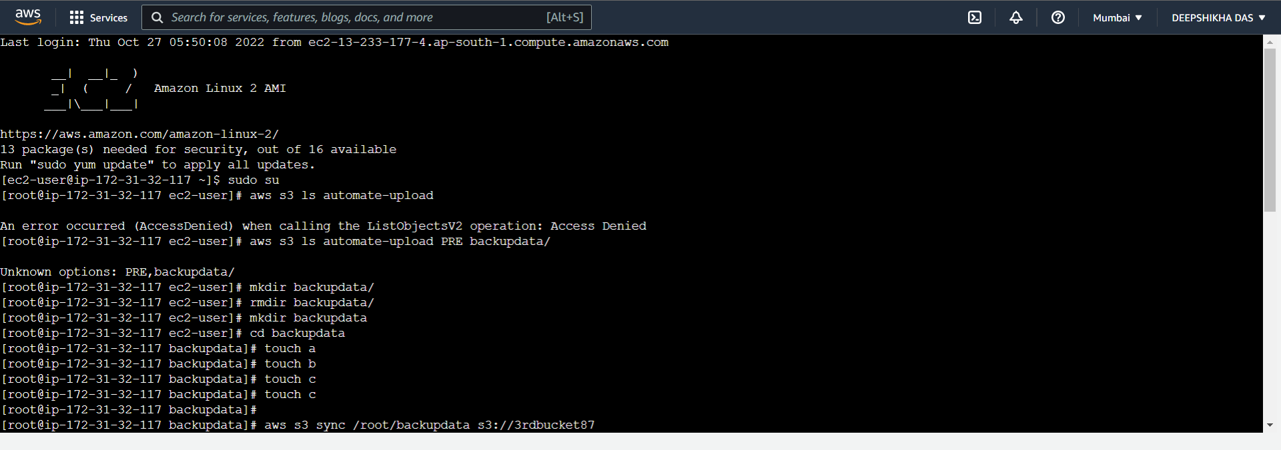

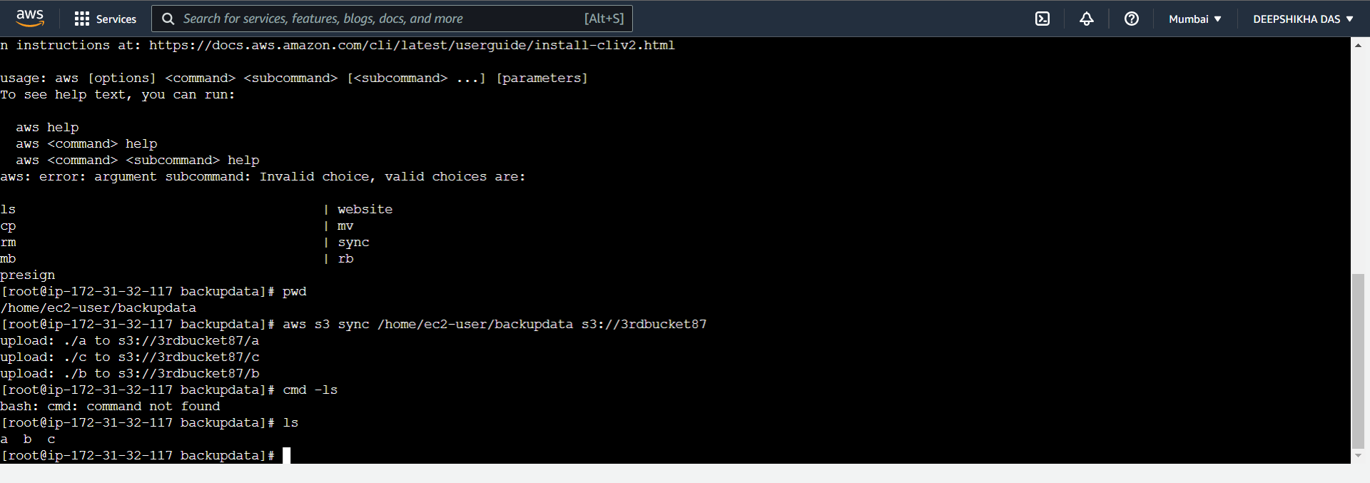

12.Restart the Crond service

Run “systemctl restart/stop/start cornd.service” to restart/stop/start your cron

jobs respectively.

13.Now, we are going to create some test files to check if they are uploaded

every minute or not.

We have successfully automated our local files/directory backup on Amazon S3

buckets using crontab.

14.File d an d file e have been updat ed

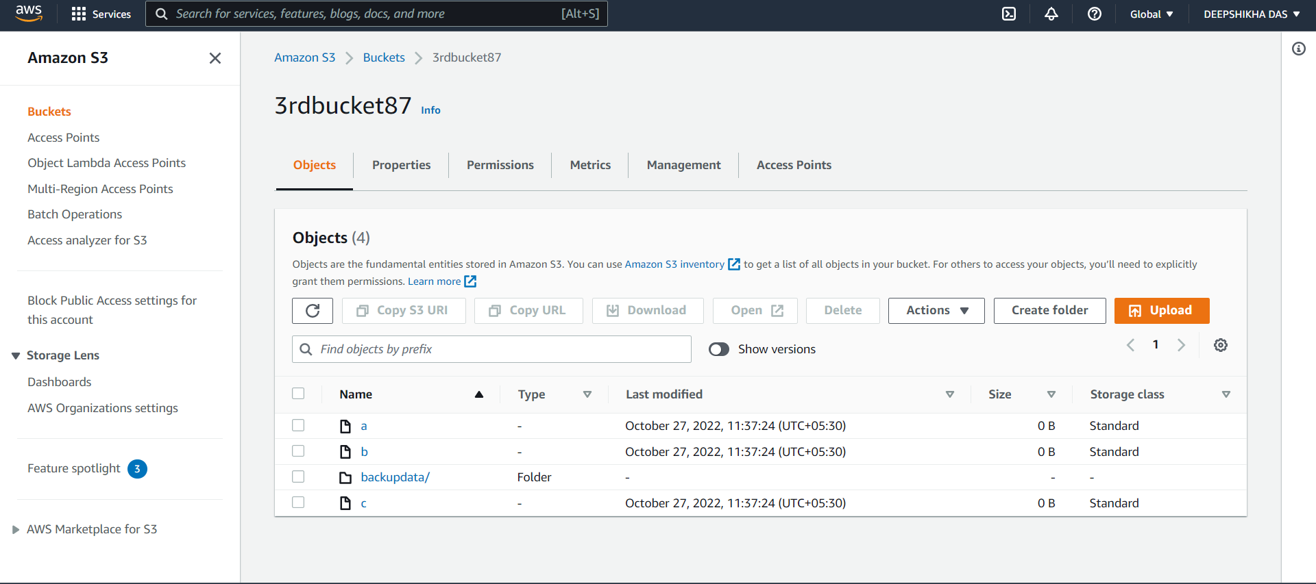

***Result:***

We have successfully automated our local files/directory backup on Amazon S3 buckets using crontab.